Univariate Analysis of Body Fat Prediction Dataset

Below is the Univariate Analysis result of Body Fat prediction dataset:

Dist Plot: Weight
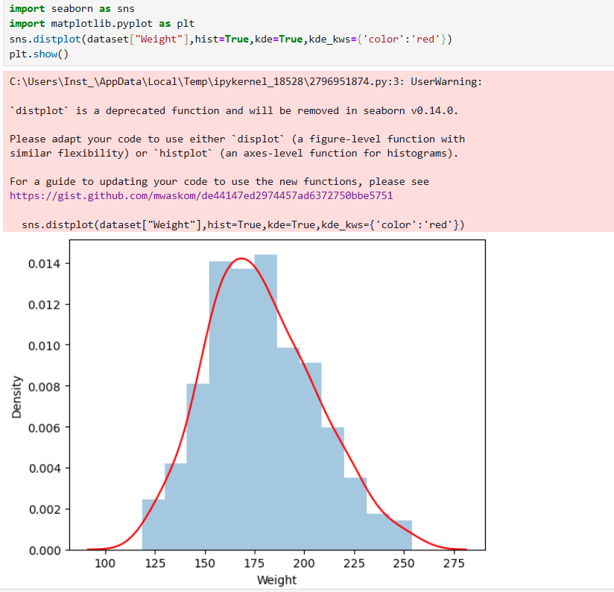

INSIGHTS:
- Most of the men members weigh from 150 to 200 pounds
- Members with low weight to high weight are available in the dataset
- Members with small, medium and large frame are available in the dataset

Dist Plot: Height
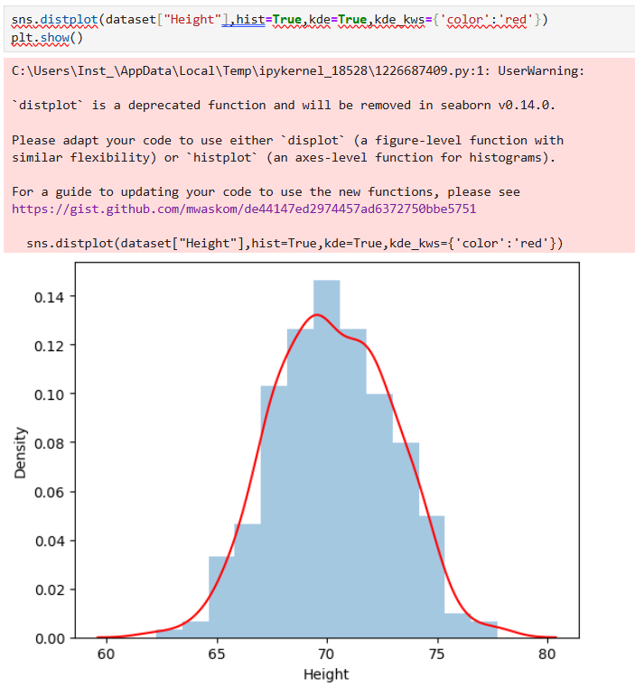

INSIGHTS:
- Most of the members have heights ranging from 68 to 73
- Members with different height categories are available. i.e short, average and tall members are available in the dataset

Dist Plot: BodyFat
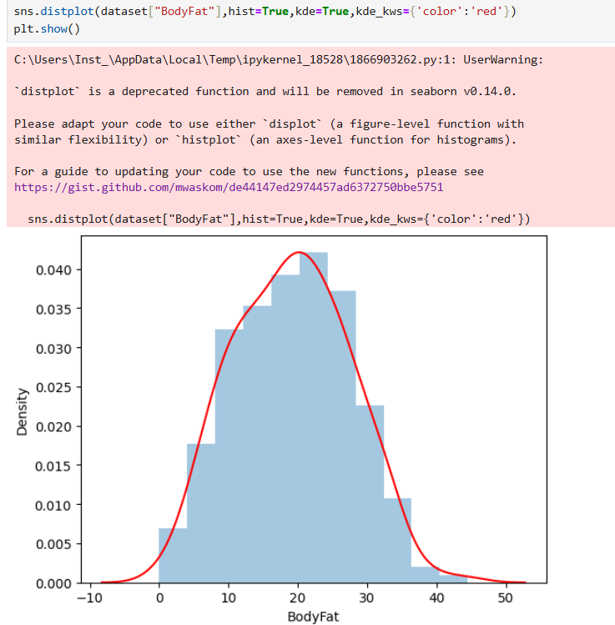

INSIGHTS:
- Most of the members have body fat values ranging from 8 to 30%
i.e most of the members falls under healthy and overfat category
- There is a member who has a body fat value of ‘0’ in the dataset. This should be analysed further and replaced with an appropriate value
- Members who have lowfat, overfat and healthy fat are available in the dataset

Dist Plot: Age
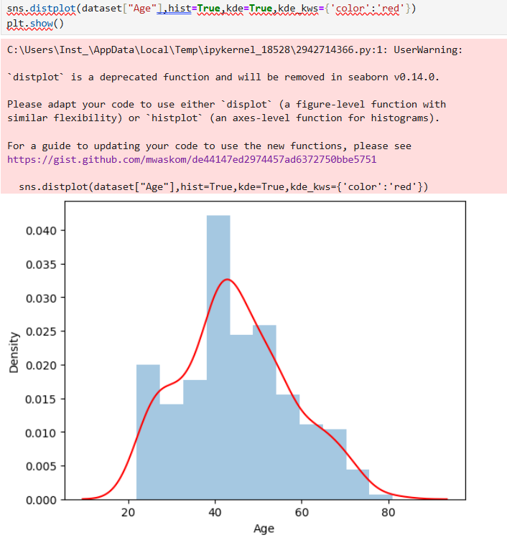

INSIGHTS:
- Most of the members have an age range from 40 to 55 i.e most of their members are in their 40’s or 50’s
- There are some aged members in the dataset (age 70-80)

Box Plot: Neck
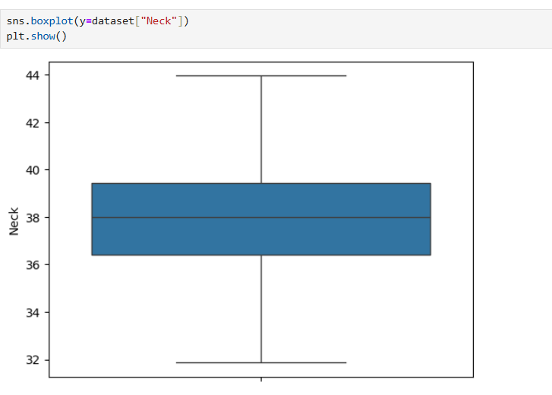

INSIGHTS:
- Min and max values of neck measurement of members are 32 and 44 respectively
- 25% of the members have neck measurements around 36.2(Q1-value)
- Median value of the neck measurement is 38
- 75% of the members have neck measurements around 39.2(Q3-value)

Box Plot: Thigh
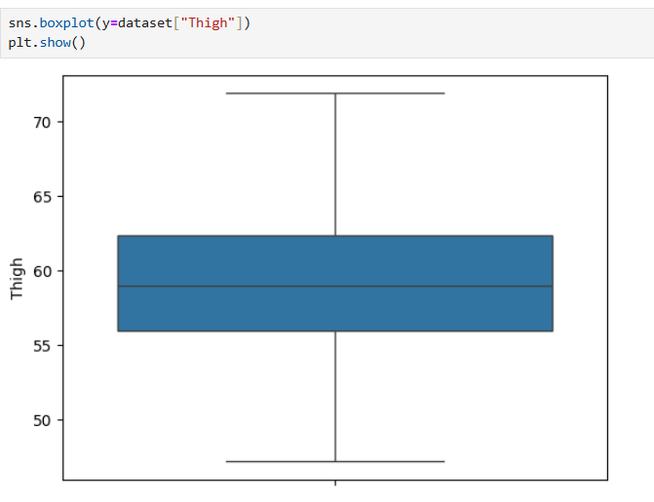

INSIGHTS:
- Min and max values of neck measurement of members are 47.2 and 71.85 respectively
- 25% of the members have neck measurements around 56(Q1-value)
- Median value of the neck measurement is 59
- 75% of the members have neck measurements around 62.35(Q3-value)

Box Plot: Chest
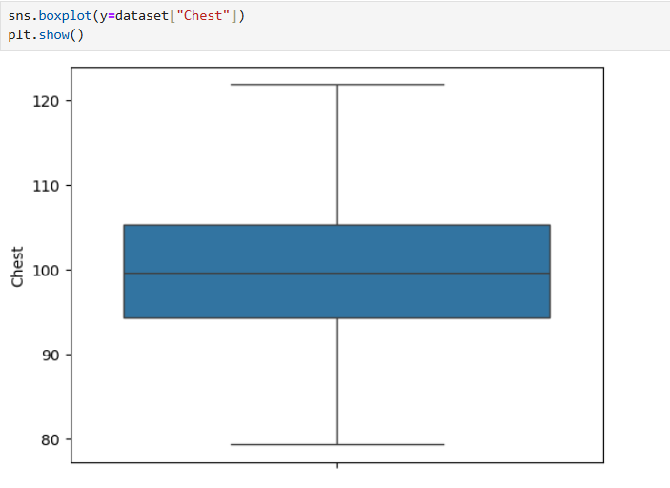

INSIGHTS:
- Min and max values of Chest measurement of members are 79.3 and 121.91 respectively
- 25% of the members have Chest measurements around 94.35(Q1-value)
- Median value of the Chest measurement is 99.65
- 75% of the members have Chest measurements around 105.37(Q3-value)

Box Plot: Hip
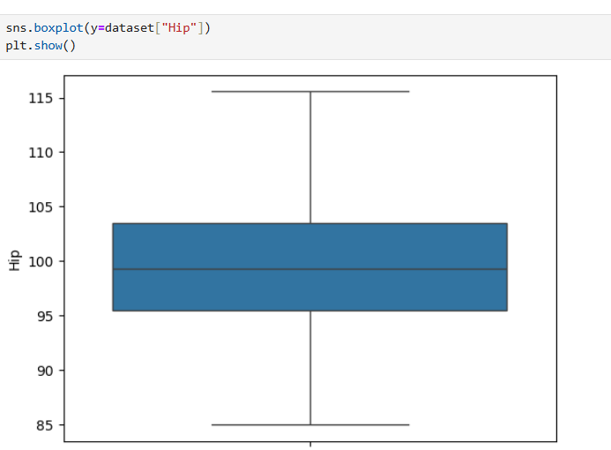

INSIGHTS:
- Min and max values of Hip measurement of members are 85 and 115.5 respectively
- 25% of the members have Hip measurements around 95.5(Q1-value)
- Median value of the Hip measurement is 99.3
- 75% of the members have Hip measurements around 103.5(Q3-value)

Box Plot: Biceps
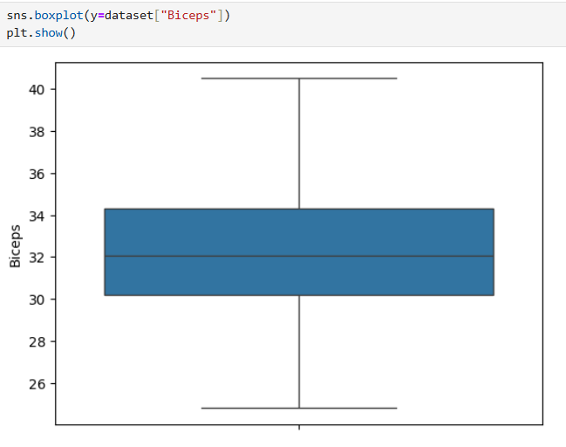

INSIGHTS:
- Min and max values of Biceps measurement of members are 24.8 and 40.5 respectively
- 25% of the members have Biceps measurements around 30.2(Q1-value)
- Median value of the Biceps measurement is 32.05
- 75% of the members have Biceps measurements around 34.3(Q3-value)

Box Plot: Forearm
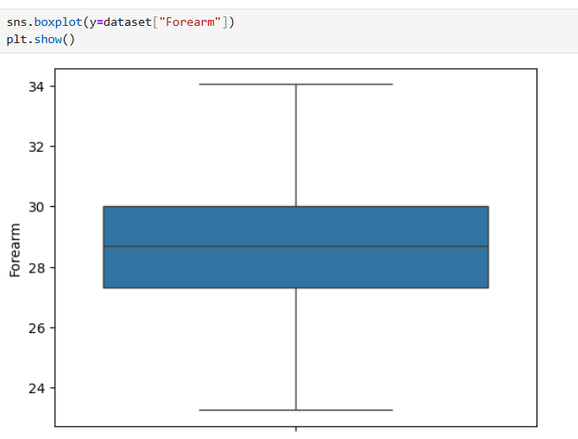

INSIGHTS:
- Min and max values of Forearm measurement of members are 23.25 and 34.05 respectively
- 25% of the members have Forearm measurements around 27.3(Q1-value)
- Median value of the Forearm measurement is 28.7
- 75% of the members have Forearm measurements around 30(Q3-value)

Box Plot: Wrist
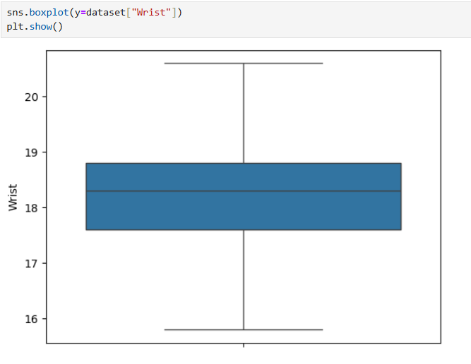

INSIGHTS:
- Min and max values of Wrist measurement of members are 15.8 and 20.6 respectively
- 25% of the members have Wrist measurements around 17.6(Q1-value)
- Median value of the Wrist measurement is 18.3
- 75% of the members have Wrist measurements around 18.8(Q3-value)

Box Plot: Knee
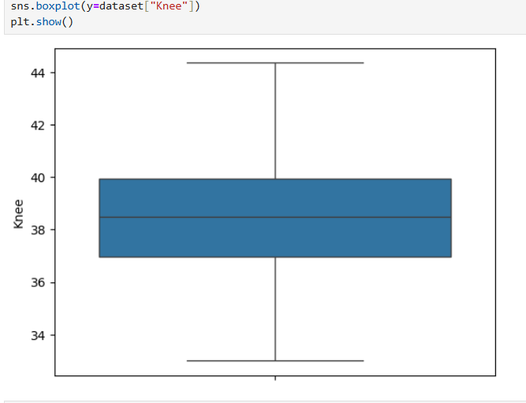

INSIGHTS:
- Min and max values of Knee measurement of members are 33 and 44.35 respectively
- 25% of the members have Knee measurements around 36.97(Q1-value)
- Median value of the Knee measurement is 38.5
- 75% of the members have Knee measurements around 39.92(Q3-value)

Box Plot: Ankle
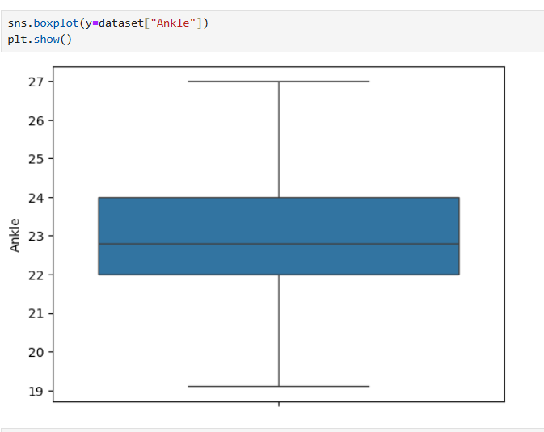

INSIGHTS:
- Min and max values of Ankle measurement of members are 19.0 and 27 respectively
- 25% of the members have Ankle measurements around 22(Q1-value)
- Median value of the Ankle measurement is 22.8
- 75% of the members have Ankle measurements around 24(Q3-value)

